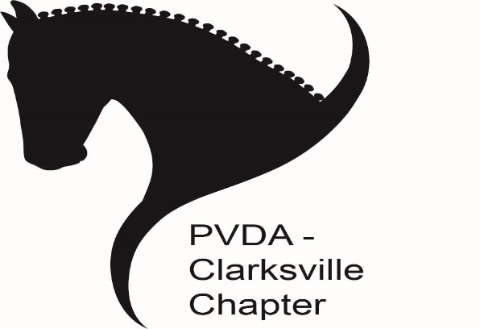
PVDA Clarksville Chapter Winter Schooling Show #1
Sunday, December 11, 2022
Stonebrook Farm, 6300 Guilford Road, Clarksville, MD 21029 Judge: Jessie Ginsburg (r)
Show Manager:  Pam Deem-Hergan  Clarksville.pvda1@gmail.com  (443) 386-1536 | Open:  11/10/2022  Registration:  Striderpro.com  **Online entries only** | Close:  12/1/2022  @7:00 pm
Classes: $25 each  PVDA non-member fee: $10 | *Show will close early if oversubscribed | Show/Costume Theme:  “Winter Holiday”

Classes: All USEF/USDF levels including lead line through FEI, Event tests, and Western dressage. 2023 Dressage tests in effect for this show.
Series End Awards: Awards will be given at each level with three or more qualifying riders. Eligible levels include Introductory, Training Level, First Level, Second & Above, MFS, Western dressage, and Event tests. To be eligible, a rider must attend minimum of two shows and complete three rides at the same level with the same horse/rider combination. Musical freestyle competitors are required to attend two shows and complete two rides. For rider/horse combinations with more than two rides, the lowest score will be dropped, and all other scores averaged. For rider/horse combinations with two rides, both scores will count. A minimum average of 55% is required.
Registration: Reserve a spot via http://www.striderpro.com. Only completed online entries via StriderPro will be accepted. A completed entry includes the online StriderPro entry form, current coggins, proof of PVDA membership (or non-member fee), & payment. Entries are accepted in order in which they are received. Striderpro registration does not guarantee entry.
Trailer parking: There is limited parking and backing up will likely be required. If you are trailering with more than one horse, please specify the size of your rig, the number of entrants and their names.
Payment: Payment must be completed through the StriderPro site when entering online or alternative payment arrangements must be made with the show manager. PVDA VOLUNTEER CERTIFICATES ARE NOT accepted at Chapter events for payment. If you have Clarksville Chapter volunteer credits, please contact the show manager regarding payment.
Times: Will be posted on the Chapter Facebook page and emailed to participants no later than Thursday before the show.
Additional Information: Small outdoor arena for warm-up - weather permitting. Regulation size indoor arena with sound system for musical freestyles. Classes will be run out of order and may not be pinned until the end of the day. NO REFUNDS for scratches made after the closing date. Refunds will be issued in the event of show cancellation. However, Striderpro.com service charges/credit card processing fees ARE NOT refundable under any circumstances (ex. scratches made before closing date, entry moved to wait list, or the show is cancelled).

Scholarship Raffle: After the completion of the winter series the Clarksville Chapter will award two $100 scholarships toward any horse related activity. Each ride receives one raffle ticket and four hours of volunteer service receives one raffle ticket. One scholarship will be drawn from riding tickets and one from volunteer tickets. Clarksville Chapter officers are not eligible to participate.

