***Friday Night Jump Club***

Starting June 2 continuing every other week

June 2, 16, 30

July 14,28

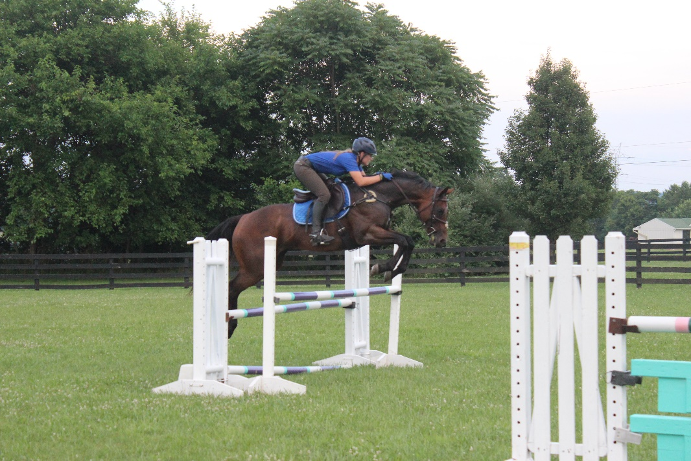Aug 11, 25 Practice your show jumping on new courses in a laid back easy going environment.

We start at *4:00 pm* at the low level

12-18” and gradually increase

heights, ending at *8:00 pm* with Prelim height of 3’7”.

$15.00 1st round 10.00 others- Come on

your own or bring an instructor, your choice.

Access to EPIC trails after you finish to mellow out your weekend.

Questions: Marie [marie@willowoak.biz](mailto:marie@willowoak.biz) or Shelley [shelleyheron@me.com](https://mail.aol.com/webmail-std/en-us/suite)

***Friday Night Jump Club***

Starting June 2 continuing every other week

June 2, 16, 30

July 14,28

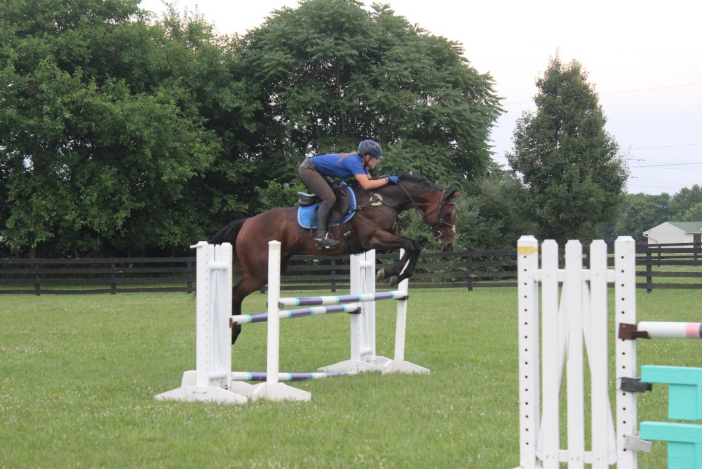Aug 11, 25 Practice your show jumping on new courses in a laid back easy going environment.

We start at 4*:00 pm* at the low level

12-18” and gradually increase

heights, ending at *8:00 pm* with Prelim height of 3’7”.

$15.00 1st round 10.00 others- Come on

your own or bring an instructor, your choice.

Access to EPIC trails after you finish to mellow out your weekend.

Questions: Marie [marie@willowoak.biz](mailto:marie@willowoak.biz) or Shelley [shelleyheron@me.com](https://mail.aol.com/webmail-std/en-us/suite)