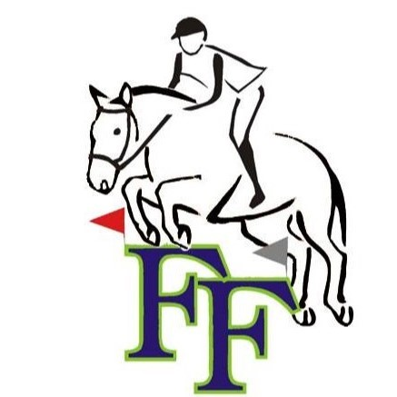

Frazier Farm Training Center
335 Middle Road Turnpike
Woodbury, CT 06798
(203) 263-2627

2020 COMBINED TEST * August 30, 2020
Start times will be emailed- include legible address
Or check the website www.frazierfarmct.com on the shows/events page

Classes $60.00
May be divided into junior & senior if entries warrant

- Intro: USDF 2019 Intro Test C
Fences not to exceed 18”. No oxers or combinations
- Elementary: USEA 2018 Beginner Novice Test A Fences not to exceed 2’3”. May have oxers, no combinations
- Beginner Novice: USEA 2018 Beginner Novice Test B Fences not to exceed 2’6”.
- Novice: USEA 2018 Novice Test A Fences not to exceed 3’0”.
- Training: USEA 2018 Training Test A
Fences not to exceed 3’3”.

Entry from and Release:
Please send to Frazier Farm Training Center 335 Middle Road Tpk. Woodbury, CT 06798
-------------------------------------------------------------------------------------------------------------------------------------

Rider:__________________________________________________________ Age:______________________

Address:________________________________________________________________ Zip:_______________

Telephone: ( )_____________________ e-mail address:________________________________________

Owner:____________________________________________________________________________________

Address:________________________________________________________________ Zip:_______________

Telephone: ( )____________________ e-mail address:_____________________________________

Division Horse Name Age Height Color Sex Entry Fee

Optional XC Schooling = $25

Special requests:____________________________________________________________________________

I enclosed herewith a total of $___________ for the aforementioned entry, which is made at my own risk and subject to the conditions of the sponsoring Horse Trials and, where applicable, the regulations of the USEA. I understand that neither the Organizing
Committee, nor the employees and owners of the Frazier Farm accept any responsibility for accidents, damage, injury, or illness to the horses, owners, riders, employees, attendants, spectators, or any other person or property owners in connection with this event.
Furthermore, in regards to COVID-19 protocol, I agree to retract my entry in the event I become ill. While at Frazier Farm, I agree to practice social distancing, and, when distancing is not possible, will implement the use of a face mask.

Print Name: ___________________________________________________

Signature:_____________________________________________________ Date:____________________

(Note: A Parent or Guardian must sign entry if competitor is under 18 years of age.)

Parent/Guardian Signature: ________________________________________ Date:___________________

