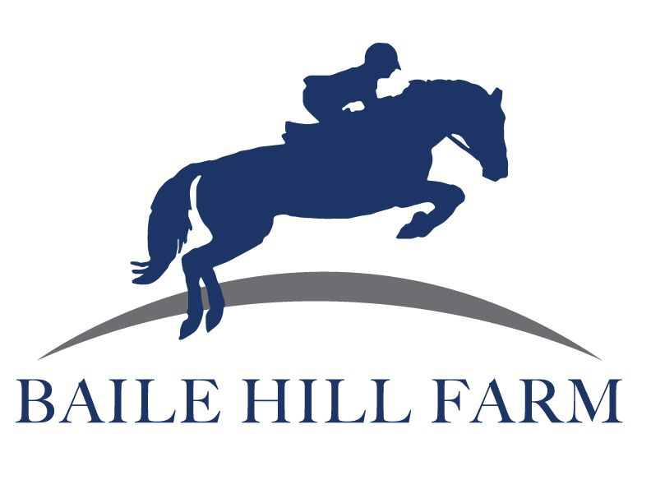
BHF COVID-19 PLEDGE
In the spirit of community, transparency, conscientiousness, and acknowledgement of the seriousness of the pandemic that Massachusetts and our country is experiencing, I pledge to follow all rules outlined below when I enter the Baile Hill Farm property. I understand that when I enter the property to visit or handle my horse I enter the property and buildings at my own risk and with risk to the other members and staff. I sign this pledge acknowledging that I am working to minimize those risks as much as possible.
-I agree that I am currently healthy and without any symptoms of COVID-19 (which include but are not limited to: fever over 100, shortness of breath, cough, sore throat, vomiting, less of smell/taste, diarrhea, and other symptoms listed with the current CDC).
-I agree to let Jess know if I have tested positive for COVID-19. I will be required to have 2 negative tests within a 24 hour period of each other and a doctors note in order to return to the property.
-I agree to take my temperature prior to each visit to the facility. If I have a temperature over 100 I will not come to the farm.
-I agree to practice safe social distancing on the farm-staying well away from 6’ apart from any staff, vendors, other boarders/lessors.
-I agree to wear gloves and a CDC approved mask at all times when on property. Mask can be pulled down while riding.
-I agree that I will not enter the barn building (except indoor through indoor doors) and to only use the designated areas on property.
-I agree to stay current and pay attention to email updates as barn COVID-19 policies change.
-I agree that I will keep my items and bring them with me for use each time.
-I agree that I will provide and disinfect ALL surfaces (with CDC approved disinfectant) that I come in contact with (this includes cross ties, gates, handles, pitchforks, etc.). Pitch forks will be located at muck tubs in outdoor and indoor.
-I agree that I will be use my designated time slot and not run over.
-I agree that I will continue to abide by barn rules and boarding contract during this time.
-I agree that I will come to Jess with any questions/concerns regarding current COVID-19 policies.

_____________________________________________________________________ Signature Print Name/Date

_____________________________________________________________________ Parent’s Signature Print Parent’s Name/Date (If boarder/lessor under 18)

