World Class Grooming For Horses Clinic.

[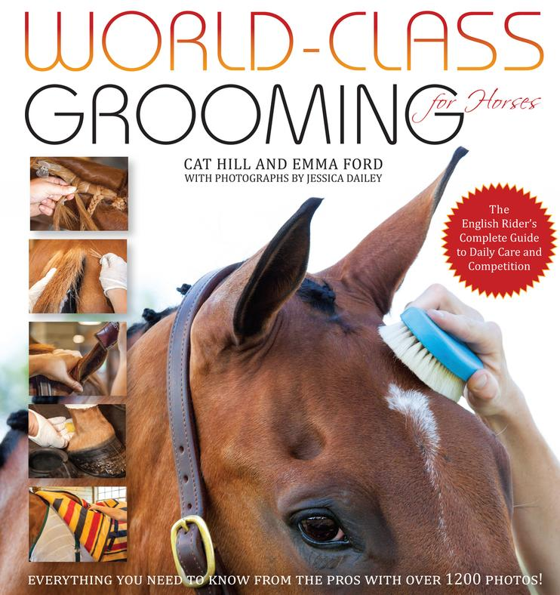](http://www.horseandriderbooks.com/mm5/merchant.mvc?Screen=PROD&Store_Code=H&Product_Code=WOCLGR&Category_Code=WCOM)

Apple knoll Farm, Millis, MA is proud to offer a two day grooming clinic with co authors Emma Ford and Cat Hill

November 7th and 8th, 2015

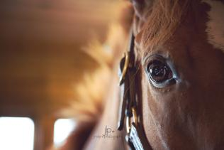

Cost: One Day Clinic $180

Two Day Clinic $290

$30 Discount per day for Pony Club members

For more details and sign up go to

[www.worldclassgrooming](http://www.worldclassgrooming) .com or www.appleknoll.com