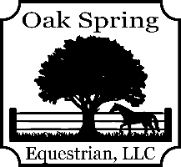
Oak Spring Equestrian, LLC
2024 Working Equitation Show Series

Show Officials:
Show Secretary/Manager: Barb Sullivan
Score Runners: Kenzie, Justin & Taryn

Show Dates:
April 6, 2024 – Kim Hillyer
May 11,2024 – Danni Toscano
June 29, 2024 – Holly Linz
July 27, 2024 - TBD
September 21, 2024 – Holly Linz

LEVELS OFFERED:
- Level 1 – Intro Dressage & EOH $80.00
- Level 2 – Novice A Dressage, EOH & Speed $100.00
- Level 3 – Novice B Dressage, EOH & Speed $100.00
- Level 4 – Intermediate A Dressage, EOH & Speed $100.00

SHOW RULES:
- A total of 15 - 20 riders will be able to register for the show.
- All divisions will run as Open - unless there are sufficient entries to split into Open/Amateur.
- The rules governing this show are USA Working Equitation. The rule book can be found at www.usawe.org.
- A horse may be entered twice at the same competition, ridden by two different riders, at the discretion of the show management. Horse can be ridden no more than (6) times in a day!
- Registration & payment will be via striderpro.com. You can access the link from the Oak Spring Equestrian Facebook page, click on events and then click on show date.
- A negative coggins and a signed OSE release are required. These can be emailed to oakspringequestrianllc@gmail.com or uploaded in striderpro.com when registering.
- NO Refunds after you register unless spot can be filled.
- ASTM/SEI approved helmets required for all competitors.
- Rider’s attire should be neat and presentable. Breeches, jeans, collared shirts permitted. Refer to the USAWE rules for tack and attire rules.

RIBBONS:
- Ribbons will be awarded from 1st – 6th in each trial & level.
- Champion & Reserve Champion ribbons will be awarded in each level. There must be at least 3 riders in a level for Champion & Reserve Champion ribbons to be awarded.

SERIES REQUIREMENTS & AWARD:
- You must compete in at least 3 shows AND on the same horse AND compete at the same level to be eligible for the series awards.
- Year-end banquet date TBD. Everyone that shows & volunteers are welcome to attend! Banquet will be held at Oak Spring Equestrian.
- Series award winners will be based on your points earned from each show. We will be using the same point system as USAWE. In the overall series standings – you will not place above another horse/rider combo if you have a DQ in any phase throughout the series. EX: Rider A has 15 points but NO DQ’s; Rider B has 18 points but a DQ in a phase. Rider B will NOT place above Rider A in the overall standings. A tie will be broken by the highest dressage average.
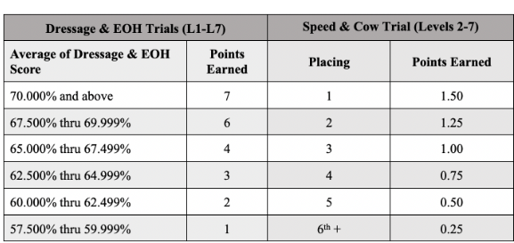

RIDE TIMES
- In working equitation – all rides are “Order of Go”. Approximate ride times will be emailed to competitors AND posted on the Oak Spring Equestrian Facebook page the Thursday before the show.
- Please recheck the day sheet when checking in for any changes to the schedule.
- Mandatory course walks with the judge will be scheduled. This is where you will have the opportunity to ask the judge questions about the course.

GENERAL INFORMATION
- Dressage to be held in the indoor arena. EOH and speed will be held in the outdoor. Warm up will be on grass. SUBJECT TO CHANGE.
- Horses must display bridle number under saddle. Please return numbers.
- Bring water for your horses. There is no water by the indoor; Closest water is at the barn.
- Please leave dogs at home.
- Please clean up after you and your horse in the trailer area. Take poop, hay and trash home.
- Portable potty beside indoor. Hand wash station available.
- Easy in/out for trailers. Parking on gravel lot and grass lots.
- (6) 12x12 pens will be available for rent for $20 a show. Paid in cash the day of to show scorer. Call/Text/Email to check availability.

LUNCH
- Potluck lunch – OSE will supply a main dish and paper goods. Please bring a dish to share if you care to take part in the meal.
- Bring your own drinks.
- Let me know beforehand if you have specific dietary needs. (Vegetarian, gluten free…) There is a refrigerator and microwave in the shop for use.

Oak Spring Equestrian, LLC
15205 Bushy Park Rd.
Woodbine MD 21797
Oakspringequestrianllc@gmail.com
Oakspringequestrianllc.com
(443)745-5067

