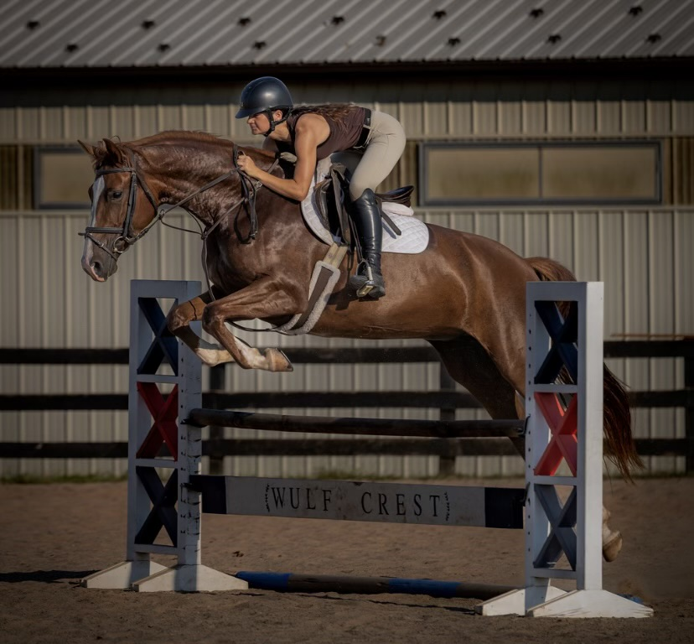  - The stables at  - Wulf Crest Farm  Jumper Schooling Show  2025 Summer Schooling Show  July 19, 2025 and August 24, 2025   |  | Food on site!  Entry Fee: $20/class  $  classes for everyone!  Online Entries: STRIDERPRO.COM  CHECK OUT OUR FACEBOOK FOR UPDATES  The Stables @ Wulf Crest Farm  19876 Rider’s Success Ln  Leesburg, VA  Wcfstables.com
Wulf Crest Farm Rules and Regulations

Office Fee: A $15 office fee will be charged per rider

Entries: Management has the right to limit the entries at the show to comply with State, County, and local capacity restrictions. No office fee refund if you scratch day of show.

Coggins Test: Prior to the show, all exhibitors must submit an electronic copy of a Negative Coggins test taken within one year on each animal exhibited. Please upload to strider or email coggins to shows@wcfstables.com

Entry Fee: $35.00 per class.

Schooling: Schooling is permitted in the show ring from 7:30 am -8:30 am. Additional schooling breaks will be offered if time permits. Open card un-judged warm-ups will be available if time permits.

Responsibilities: Horse show staff and volunteers will not be responsible for any accident, or loss, which may occur to any exhibitor, spectator, rider, guest, groom attendant, or other employee, animal or equipment at the show. The show reserves the right to decline or accept any entry and return any entry fees before or during the show without being liable for compensation; combine, cancel, split or limit any classes; or change any officials.

Dogs: All dogs must be on leashes while on the show grounds.

Awards: First round clear blue ribbon. Second class six ribbons per class.

Wulf Crest Farm Horse Show Schedule

Jumper Show
Outdoor Ring 9 a.m. Start

- Poles
- Crossrails (18”)
- Baby Jumpers (2’)
- Puddle Jumpers (2’3”)
- Mini Jumpers (2’6”)
- Hopeful Jumpers (2’9”)
- Low Jumpers (3’)
- Schooling Jumpers (3’3”)
- Modified Jumpers (3’6”)
- More heights offered, just ask the in gate!

