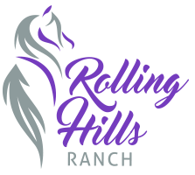

Rolling Hills Ranch – Horse Health Declaration Form

33 Rolling Hills Ranch Lane

Port Deposit, MD 21904

Rolling Hills Ranch – Horse Health Declaration Form

Event/Show Name: __________________________ Date: ____________________

**Horse Information**

Horse’s Name: _________________________ Age: _____

Breed:__________________

Owner’s Name: ___________________________________________

Address: ______________________________________________

Phone: __________________ Email: ___________________

**Health Declarations**

1. My horse(s) have not attended any shows or facilities with known strangles outbreaks in the last 60 days.

2. I understand that entries are not considered complete until all required documentation is submitted.

**Acknowledgment**

I acknowledge that withholding information or submitting false information regarding my horse’s health may result in dismissal from the premises without refund, and may jeopardize my ability to compete in future Rolling Hills Ranch Events.

Owner/Exhibitor Signature: __________________________ Date: ___________