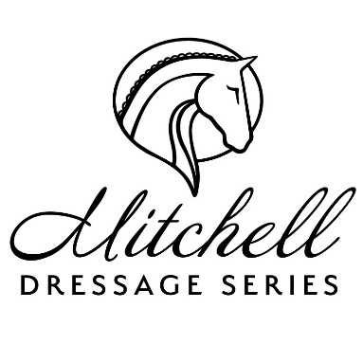
LIABILITY RELEASE:
I hereby agree that I am participating voluntarily in an Equine Activity, which includes, but is not limited to, any and all Equine Activities (such as Horse Sports, Competitions, Trail Riding, Pleasure Riding, Visiting Equine Facilities, and daily activities related to Care and Grooming, etc.), and acknowledge that ANY kind of Equine Activity involves inherently dangerous risks including, but not limited to, (1) the propensity of a horse to behave in a dangerous way; (2) the inability to predict a horse’s reaction to sound, movement, objects, persons, or animals; (3) hazards of surface or subsurface conditions; and (4) the possibility of equipment breakage; any and all of which may result in serious injury or death to myself and/or others, to my child/ward, horse or to property.

Therefore, I agree to in consideration for being permitted participate in this equine activity, I expressly assume any and all risk of injury or loss to my persons, including any person in attendance with me, animals, equipment, and agree to indemnify and hold harmless Mitchell Dressage Series, Vintage Valley Sport Horses, Kelly’s Ford Equestrian Center/Southern Heritage Farm, Owners, family members, officials, independent contractors, employees, or any and all associated with the Mitchell Dressage Series and/or Vintage Valley Sport Horses, Kelly’s Ford Equestrian Center/Southern Heritage Farm from and against any and all claims, demands, causes of action and liability of any nature which arises from connection with said Farm, owners, agents, event, et. al., including claims resulting directly or indirectly from alleged negligent acts or omissions of any owners, family members, independent contractors, employees, officials or anyone associated with Mitchell Dressage Series, Vintage Valley Sport Horses, Kelly’s Ford Equestrian Center/Southern Heritage Farm, or event.

This agreement is binding upon myself, my spouse, legal representatives, heirs, executors and assigns.

Mitchell Dressage Series and Vintage Valley Sport Horses, Kelly’s Ford Equestrian Center/Southern Heritage Farm are not responsible for lost, stolen, or damaged property belonging to the Rider, nor any injury, illness, or death to the above horse(s).

This release is valid from the date indicated below as well as all future equine activities held at Vintage Valley Sport Horses, Kelly’s Ford Equestrian Center or Southern Heritage Farm until the end of the current calendar year.

I have read, understood, and agree to abide by this and all of Mitchell Dressage Series and Vintage Valley Sport Horses, Kelly’s Ford Equestrian Center/Southern Heritage Farm policies.

PRINT RIDER NAME: _________________________________________________________

SIGNATURE of RIDER or PARENT/GUARDIAN (if rider under age 18) :

___________________________________________________ DATE: ________________

