AEC Prep Clinic
Majestic Oaks, Ocala, FL August 9th 7:30AM-1PM
Showjumping with Jenny Caras Roberts
Cross Country with Waylon Roberts
Jenny and Waylon, recently married, are talented five star riders who have achieved much success due to their dedication, hard work and talent. Having trained with some of the very best in the world of eventing, such as Oliver Townend, Ian Roberts and Phillip Dutton, they have competed at five star events such as Rolex and Badminton. They have both attended the American Eventing Championships and have experience to share of how to prepare for championship events! They also have shown at the Kentucky Horse Park numerous times. This clinic will give insight into how to prepare yourself and your horse for the AEC’s and make the most of your competition! Don’t miss the wonderful opportunity to learn from two talented exciting riders!
Jenny
In 2016, Jenny was awarded the Karen Stives Grant which allowed her to travel to England to compete Fernhill Fortitude in the Under 25 division at the Bramham CCI4*-L. Jenny and Forty finished in 9th place amongst a very competitive field of international equestrians. In 2017, Jenny was one of the youngest riders privileged to compete at the Rolex Kentucky CCI5*. For the sixth consecutive year, Jenny was chosen as one of 10 top riders in the United States to be selected to the USEF Eventing 25 Training List. In 2018, Jenny and Forty flew to the UK and trained under Oliver Townend. They competed at Badminton CCI5* before returning home to the states. Since then, Jenny has brought Trendy Fernhill up to the advanced level with their sights set on a CCI4*-L at the end of 2020.
Waylon
Waylon was born into the sport of eventing— his mom Kelly went to the 1988 Los Angeles Olympics, and dad Ian went to the 2004 Athens Olympics. In 2009, Waylon spent a year training with Oliver Townend, then a year with Tiny Clapham. While in the UK, he was able to compete throughout the British Eventing circuit, including both Bramham and Boekelo. He also rode for Phillip Dutton before establishing his own US-based business, WR Sporthorses. Waylon again represented team Canada at the 2017 Pan Am games in Toronto on his horse Bill Owen, where they won team bronze. In 2018, he successfully completed the CCI 5* Land Rover Kentucky Three Day Event with Kelecyn Cognac. Waylon returned to Kentucky in 2019, this time completing the CCI 5* with Lancaster for a top 25 finish. He is also the 7-time winner of the Royal Winter Fair Indoor Eventing Challenge in Toronto.
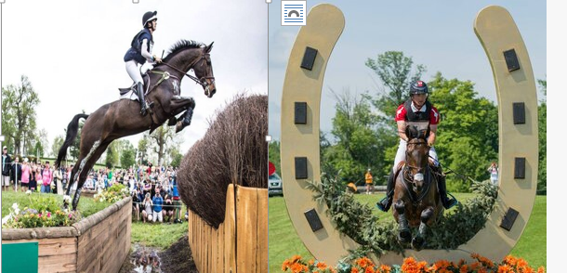
Contact Krista Wilson at krista.wilsonkw1@gmail.com or text (813) 562-5571 for more information!

