THOROUGHBRED DAY AT BRIGADOON
Presented by Aspire Equine
An Educational Thoroughbred Jumper Clinic & Competition
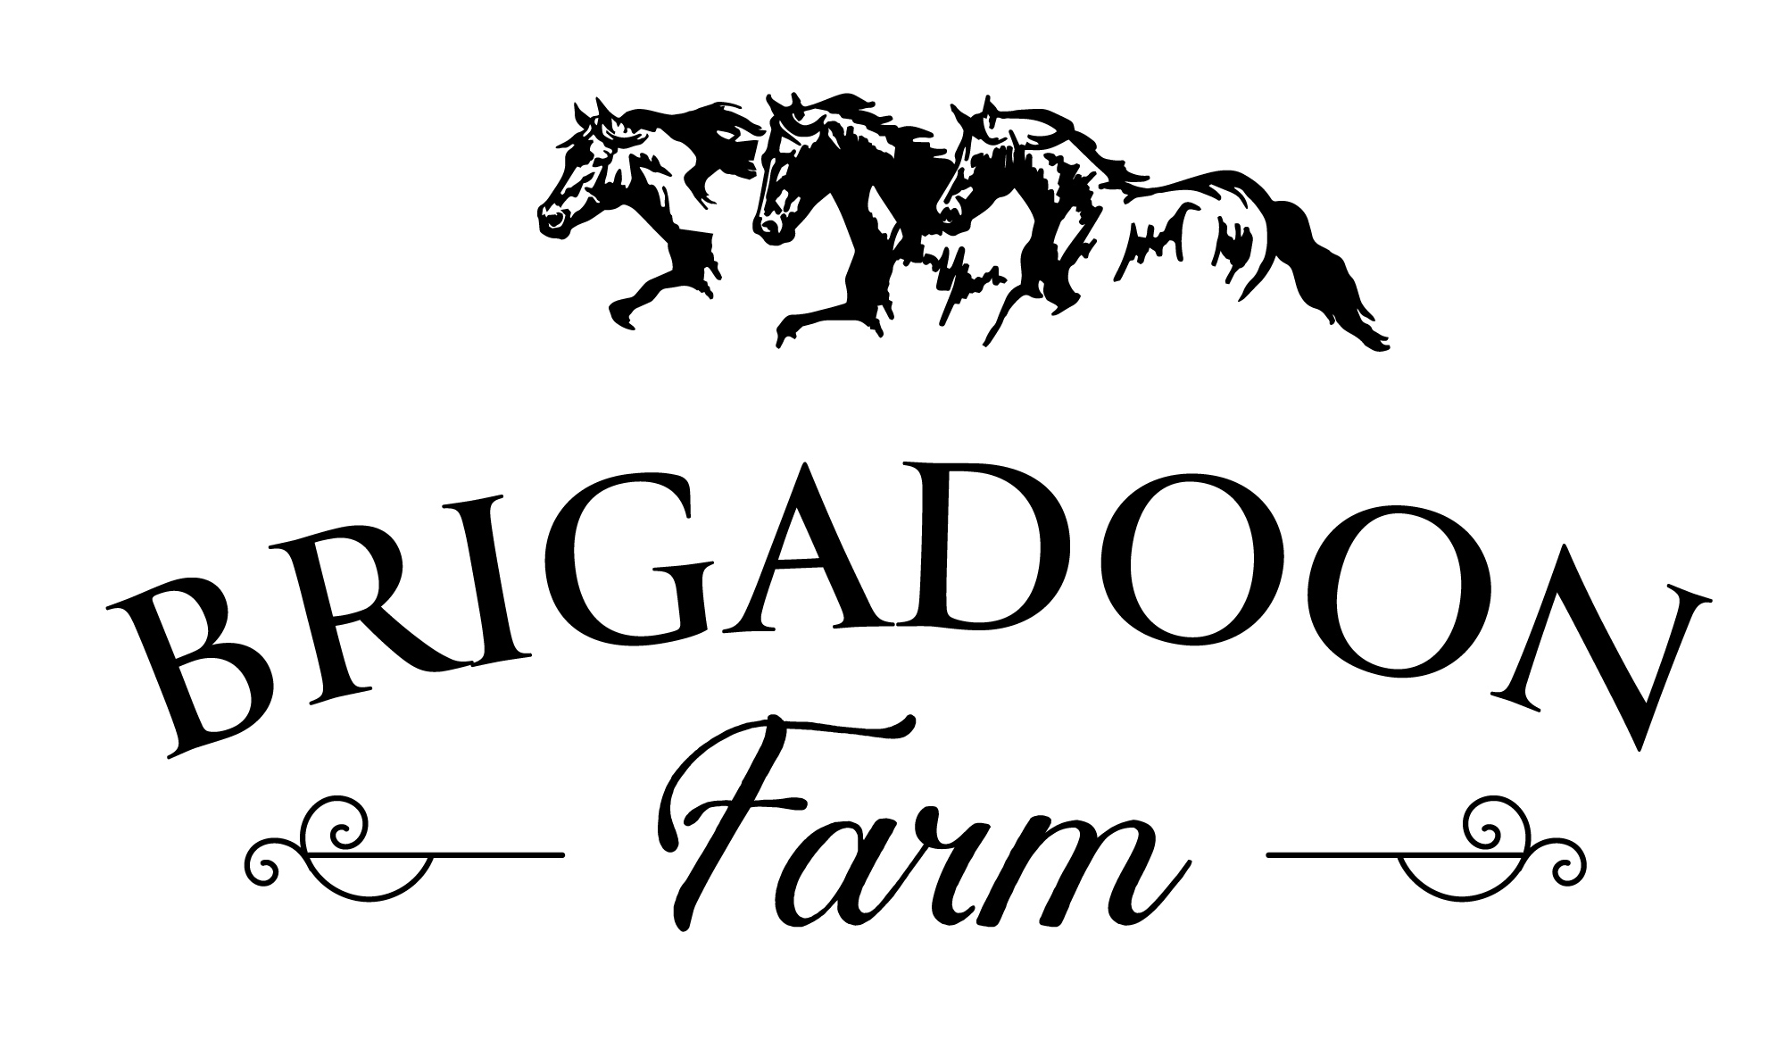

Date & Location
Saturday, July 11, 2026
Brigadoon Farm
6489 John S. Mosby Highway
Middleburg, Virginia

Event Overview
Thoroughbred Day at Brigadoon is a boutique educational jumper clinic and competition experience designed exclusively for Thoroughbreds. Combining mental strategy instruction, applied jumper rounds, and collaborative rider feedback, this unique format provides riders the opportunity to immediately apply learning in a supportive and thoughtfully competitive environment.
Enrollment is intentionally limited to ensure individualized instruction, meaningful feedback, and an exceptional rider experience.
This competition is affiliated with the East Coast Thoroughbred League (ECTB), and participating classes will count toward ECTB Year-End High Score Awards.

Featured Clinician & Officials
Clinician/Judge: Jazz Napravnik
Judge & Show Consultant: Terri Young
Gate Person / Announcer: Nina Davis
Course Design: Jazz Napravnik & Terri Young

Clinic Format
Each section will include:
• Mental strategy and mounted instruction
• Applied jumper competition rounds
• Collaborative rider feedback and discussion
Approximate Structure Per Height Section:
• 45 minutes of mounted clinic instruction
• Two competition rounds:
- Optimum Time Round
- Table II, Section 2B Jumper Stake Round
• Group rider debrief and feedback session

Divisions & Classes
Cross Rail Jumpers
• Optimum Time
• Table II, Section 2B Jumper Stake
.70 Meter Jumpers
• Optimum Time
• Table II, Section 2B Jumper Stake
.80 Meter Jumpers
• Optimum Time
• Table II, Section 2B Jumper Stake
.90 Meter / 1.0 Meter Jumpers
• Optimum Time
• Table II, Section 2B Jumper Stake

Tentative Schedule
7:00 AM – 8:00 AM | Coffee & Pastries
8:00 AM – 9:45 AM | Cross Rails
10:00 AM – 11:45 AM | .70 Meter
12:00 PM – 12:30 PM | Lunch Break / Ring Drag
12:30 PM – 2:15 PM | .80 Meter
2:30 PM – 4:30 PM | .90 Meter / 1.0 Meter
5:00 PM | Reception / Q&A

Important Notes
• No formal schooling ring will be provided.
• Riders will have access to limited warm-up fences prior to competition rounds.
• The mounted clinic session is intentionally designed to prepare horse and rider for immediate application in competition format.

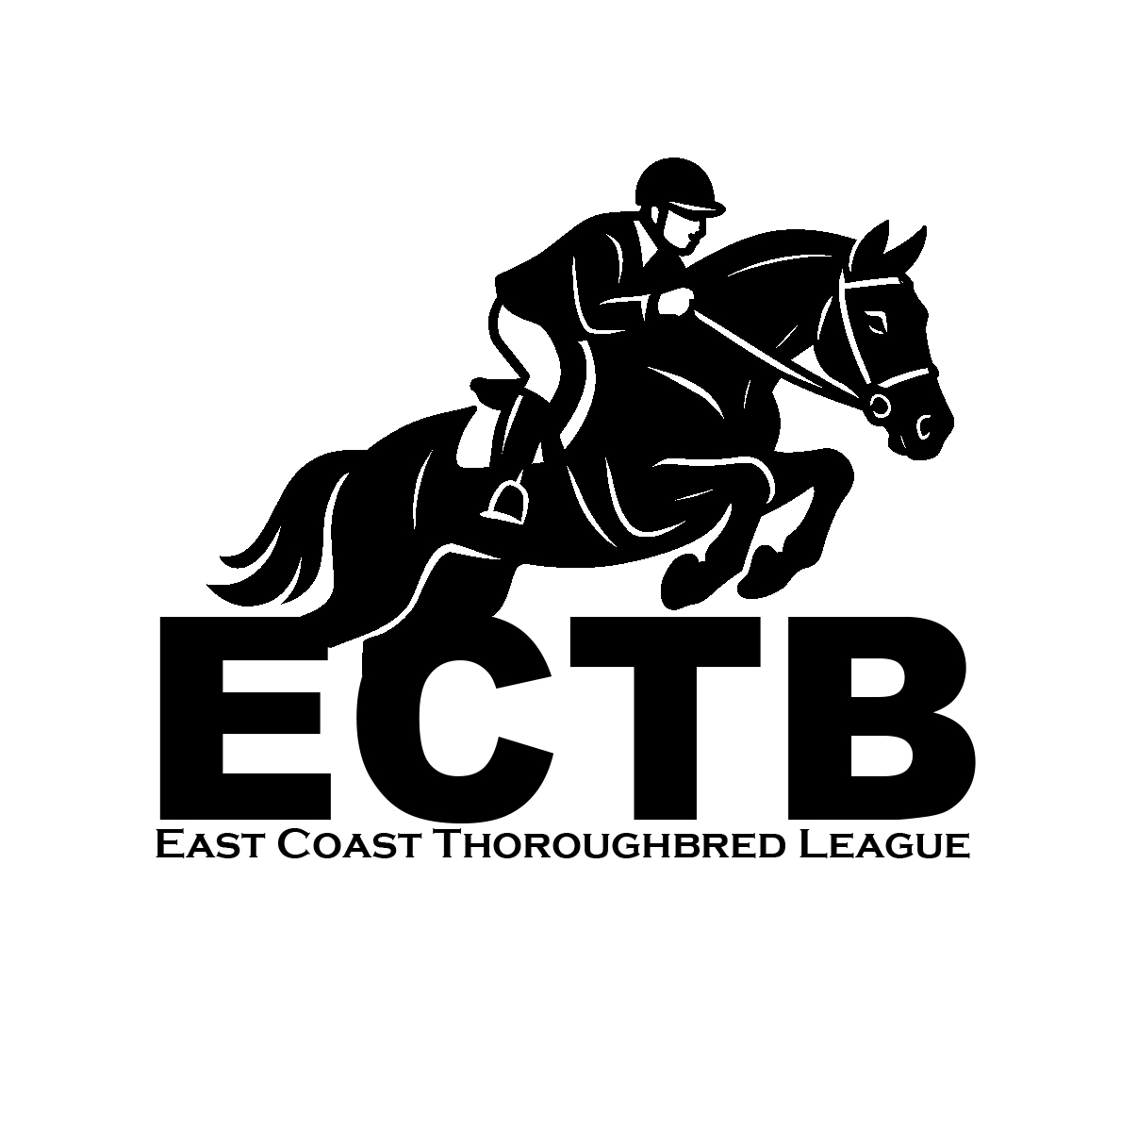

ECTB Eligibility & Rules
All participating horses must be registered Thoroughbreds.
• Participant must provide a valid TIP number if they want points to count toward ECTB.
• Only ECTB members are eligible for year-end points and awards.
League Information:
www.ectbleague.com
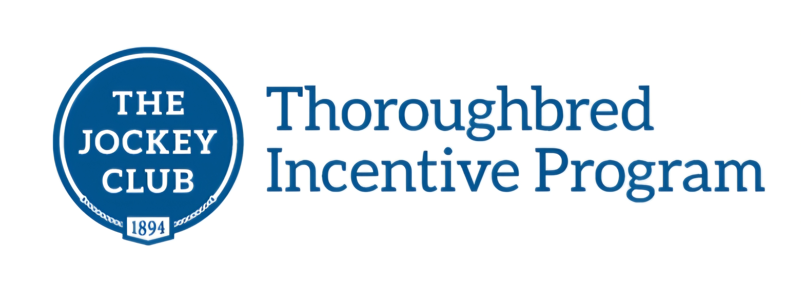
TIP Registration:
www.tjctip.com
Rules and Guidelines
• Current negative Coggins required. Use of medications or substances outside USEF Rules is prohibited.
• ASTM approved helmets must be worn at all times while riding at the Farm. No exceptions.
• Dogs must be leashed and mannerly at all times. NO EXCEPTIONS
• Brigadoon Farm, Aspire Equine and ECTB will not be held responsible for any accident, loss, or damage that can occur to any rider, horse, spectator, or equipment before, during, or after the event.
• Three competitors must complete a class for points to count toward ECTBL standings.
• Oxers are not permitted in Cross Rail or .70 Meter Jumper classes.
• Oxers may be used in .80 Meter and above with breakaway cups.
• Combinations may not be used below .80 Meter.
•Two refusals will incur elimination.
Management reserves the right to combine or divide sections based on entries.

