2021 Turner Farm Park
Dressage Schooling Show 3 & Fix-A-Test September 26th
Opens Sept. 3 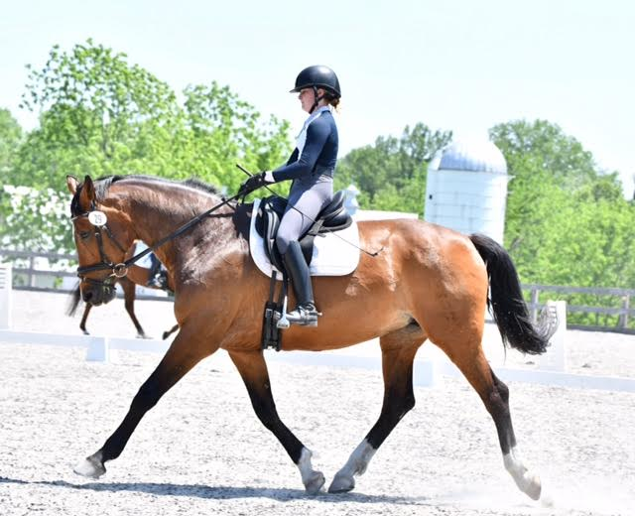 Closes Sept. 20

Come join us for our final dressage schooling show of 2021. Practice any USEF/USDF dressage or eventing tests in a low stress environment while supporting Turner Farm Park!
Schooling classes will be small, pinned classes allowing time for judge’s feedback.
Fix-A-Tests will not be pinned but include riding the test for the judge and then receiving a mini-lesson in the arena (approximately 20 minutes). It is the perfect way to build confidence for riders new or returning to showing, or trying that next level.
LEADLINE TESTS added for beginner riders age 12 and under.
Judge: Jane Seigler
For more information and to enter, go to www.striderpro.com

- Show will run in accordance with USDF rules.
- Jackets and braiding not required. Riders must approved helmets and safe and neat attire.
- No refunds after closing date. Before closing date, refund less $15 office fee.
- Ride times will be emailed on September 21.
- $20 late fee will be charged after closing date
- Current negative coggins and signed liability waiver required with entry
- No unleashed dogs. Unleashed dogs will incur $100. fine and competitor elimination.

Contact organizer with questions. Email: ngschecht@gmail.com or call at (703) 732-5130

Sponsored by West Financial Services, Inc.

